© Copyright Broadsword Interactive 1998

Controller and Replay Architecture
This document describes how the architecture of the objects which control the cars within Spirit of Speed.

Jim Finnis (jcf@broadsword.demon.co.uk)
Revision: 1.4

Created: 9/12/98
Last Revised: 14/12/98
Document State: Draft

Overview
The purpose of the controller architecture is to provide an abstract interface between a car and its control method. This way, the car does not need to know whether it’s being controlled by a player with a joystick, a player with a wheel, a player over the network, an automatic replay of an earlier game, or an AI controller. Also, new control methods can be added easily since the entire control mechanism is encapsulated within the controller mechanism.

In addition, the Controller class handles the recording of control data for the replay system, and so handles buffers for recording this data. The buffers themselves are stored in a ReplayBufferManager object.

Below the Controller class is a small hierarchy of abstract classes, which describes the difference between local controllers, which are AI and actual player controllers; network controllers, which control cars being driven by non-local players; and replay controllers, which control cars being replayed:
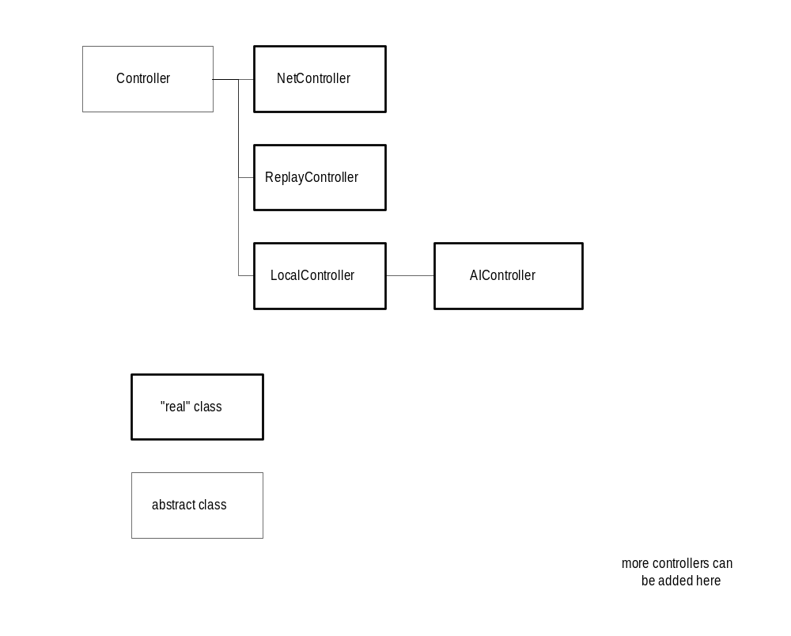
The main differences between the three top-level classes are:
- only the LocalController sends packets to the network;
- the ReplayController does not record packets to the replay buffer

Each car is attached to a single controller object, which can be any of Controller’s subclasses. The controller has a pointer back to the car.

Controller Objects in Use
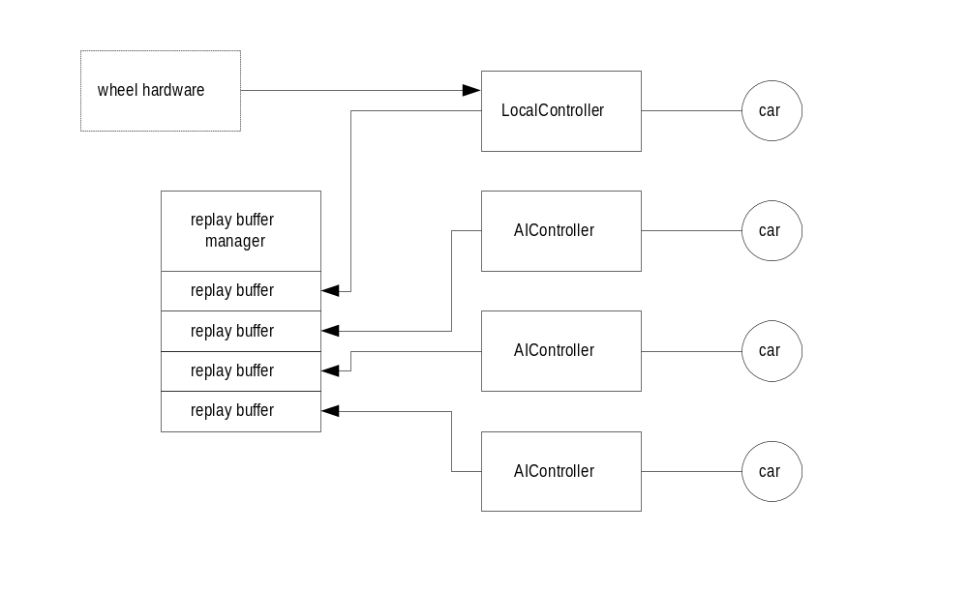In a single-player game with three AI cars and a player using a steering wheel, the following architecture holds:

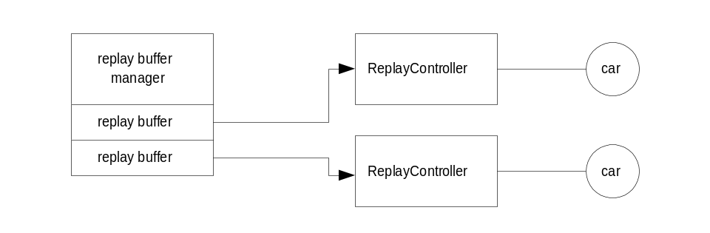In a replay situation with two cars, the following holds:
In a network game with two players and two AI cars, the following holds. In this situation, the server has the responsibility for running the AI cars – the client follows their actions using two NetControllers.

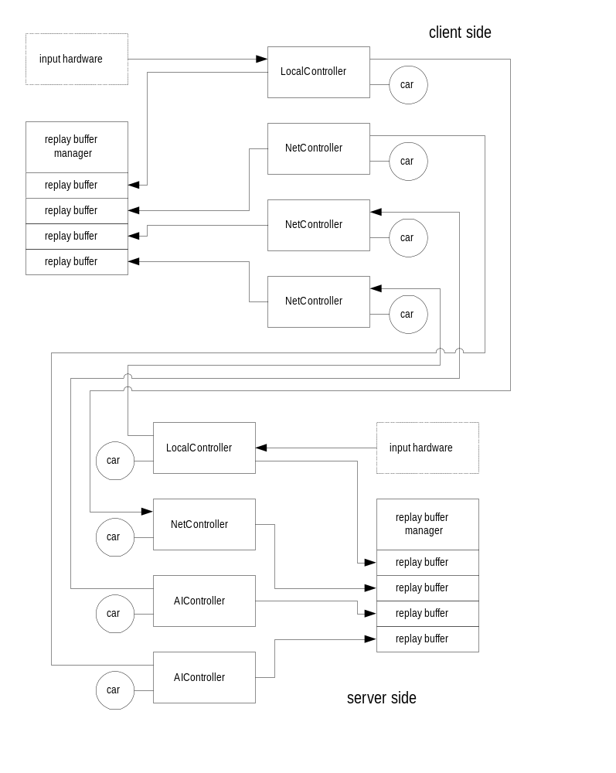

The Control Packet Class – ctrlpckt
The ctrlpckt is the data returned from all the controller objects. It has the following structure:

class ctrlpckt {

public:
short steer; // MINSHORT to MAXSHORT
short accbrake; // as above, but –ve is braking and +ve is acceleration

char flags; // should always be last. See below for values

zero(); // zero all the values

// conversion functions to/from floats

void MakePacketData(float accel,float brake,float steer); // 0..1,0..1,-1..1
void GetPacketData(float *accel,float *brake,float *steer);
};

#define CF_GEARUP 1
#define CF_GEARDN 2
#define CF_SCHARGE 4

The Controller Class (abstract class)
The Controller class is an abstract data type – that is, no objects of class “Controller” are ever created, just objects of Controller’s subclasses. Most of the methods within Controller are pure virtual methods – they are left undefined, and it’s up to the subclass to define them. The methods are:

void Attach(CarObject *car)
This attaches a car to a controller. It sets pointers in both the controller object and the car object.

virtual ctrlpckt GetControlPacket() (pure virtual function)
This returns a control packet object describing the current settings for that controller. Each subclass of controller must define this method.

virtual void SetReplayBuffer(replay *r)
This method sets the controller to point to a given replay buffer. Replay buffers are handled by the replay buffer manager (see below) to avoid repeated allocation/freeing of large amounts of memory.

virtual void SaveReplay(HFILE h)
This saves the replay buffer to a given file. The file should already have been opened and had a header written to it. This is a stub in a ReplayController.

virtual void Record(ctrlpckt p)
This adds a record a packet to the replay buffer for this controller. It may also add some other state to the controller. This is a stub in a ReplayController.

The NetController Class
This class has the same methods as above, but the GetControlPacket method has been written to read a packet from the network.

The ReplayController class, derived from Controller
In this class, the methods SetReplayBuffer, SaveReplay and Record do nothing. Calls to GetControlPacket() will return packets generated from a loaded replay buffer.

There is one additional method:

void Load(HFILE h)
This loads a replay buffer from an open file, which must have been seeked forward to the start of a buffer in the file. The replay buffer must have already been set with a call to SetReplayBuffer().

The LocalController Class, derived from Controller
Local controllers represent player cars and AI’s which are running on the machine locally. In a network game with AI cars, only the server runs the actual AI controller code – the other machines see the AI’s as a network player. The LocalController has an extra method:

void SendControlPacket(ctrlpckt packet)
This function should be called at the end of any derived GetControlPacket() methods. It sends a control packet to the network, if there a network game is being played.

LocalControllers are divided into two types:
- Player controllers, such as wheel, joystick and keyboard controllers. There will be methods (to be defined) which allow the different input devices to be bound to different control functions.
- AI controllers, which control AI cars.

Replay Architecture

replay - the Replay Buffer Class
A replay buffer is a large set of replay entries, each of which consist of control packet data interspersed with larger blocks of positional data. These large blocks are needed to avoid errors in position creeping in, and actually reposition the car object.

Because the blocks are of two different sizes, each replay buffer is simply a stream of long/float unions. The stream is made up of blocks of REPLAYBLOCKSIZE longs allocated from a large pool managed by the replay buffer manager object. The first long in each block points to the next, and unused blocks are linked in a free list. This way, the replay buffers can grow as large as necessary without malloc/free overhead, and different cars can use a different number of blocks.

The buffer has the following public methods:

replay()
This creates a replay buffer. Before it can be used, initialise must be called.

~replay()
This deletes a replay buffer and calls shutdown on it.

initialise()
This initialises a replay buffer, calling shutdown on it in case it is already active. It then allocates a head block from the buffer manager and sets the counters to zero. This is called automatically by ReplayBufferManager::AllocateBuffer().

shutdown()
This deletes all the blocks which this buffer owns in the buffer manager.

bool add(unsigned long l)
This adds a value to the buffer, growing it if necessary. False is only returned if the buffer manager ran out of room.

bool addblock(void *data, unsigned long size)
This adds a block of size bytes to the buffer, by stepping through it as longs and calling add. The block must be a multiple of 4 bytes long.

unsigned long read()
This reads the next value from the buffer and increments the pointer, switching to another buffer block if necessary. If the end of the buffer has been reached, eob will return true.

void readblock(void *data, unsigned long size)
Reads a block of size bytes from the buffer by stepping through it in longs and calling read. The block must be a multiple of 4 bytes long. The read will abort on end of buffer.

bool eob()
Returns true after the last value has been read from the buffer.

void save(HFILE h)
This saves a replay buffer to an already opened file. The actual data is preceded by a long indicating the size of the buffer.

void load(HFILE h)
This frees all the data in an existing buffer, resets the counters, and loads the buffer from a file.

The Replay Buffer Manager, ReplayBufferManager
The replay buffer manager handles all the replay buffers and the memory blocks they use. There should be only one replay buffer manager object. It has the following methods:

ReplayBufferManager()
This is the constructor, which sets up the manager for 0 buffers and 0 memory. Before it can be used it must be initialised.

~ReplayBufferManager()
This will free all the memory used by the manager, deleting both the buffers and the memory block.

initialise(unsigned long bufs, unsigned long memsize)
This initialises the manager. It takes both the number of buffers it must manage and the size of the memory block (in REPLAYBLOCKSIZE sections) which will be used. This should only be done once per game.

unsigned long *allocate()
Allocates a memory block, returning NULL if there are none left.

void free(unsigned long *)
Frees a memory block.

replay *AllocateBuffer()
This will allocate a new replay buffer, returning NULL if there are none left.

void FreeBuffer(replay *)
This will deallocate all the replay buffers. It is not possible to deallocate a single buffer. Note that deallocating these buffers will also deallocate the memory blocks they use.

From these definitions it can be seen that the replay buffer system has the following structure:

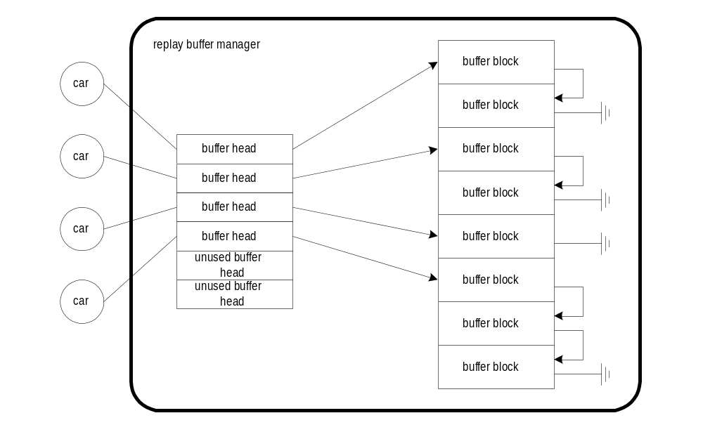

Format of Data Within the Buffers
Within the buffer, data is organised as a stream of unsigned longs, some of which are actually floats.. This stream is made up of commands, consisting of a command ID followed by zero or more arguments:

REP_END
Indicates the end of a replay buffer.

REP_CONTROL control-packet
This contains a control packet which is sent out from the buffer to the replay controller, which passes it onto the car.

REP_POSITION pospckt
This contains a position packet, which has all the information about the position of a vehicle. This packet is larger than a control packet, and so is only transmitted every few ticks. It’s used to update the position and orientation of the car and its components at the engine level. The format of a position packet is likely to be engine dependent, so I’m not detailing it here yet.

Replay Files
A replay file needs to contain information about the track, drivers and cars involved. The data format of a replay file is therefore in the following form:

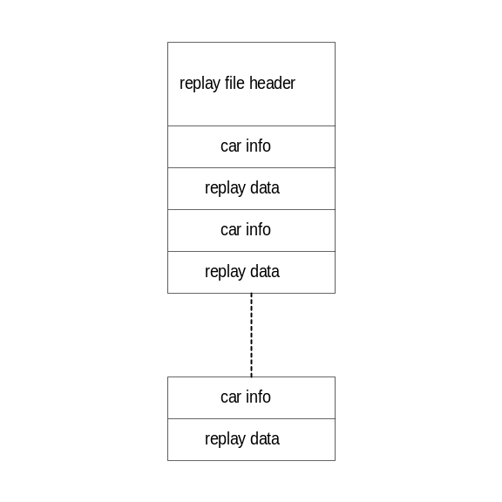The replay file header structure, ReplayFileHeader, is in the following form:

struct ReplayFileHeader
{
char track[64]; // short name of track (used to load archive)
int ncars; // number of cars
};

The car info structure, ReplayCarInfo, is in the following form:

struct ReplayCarInfo
{
char car[64]; // short name of car
char driver[64]; // driver name
};

The replay data is a replay data block as saved by replay::save(). Both these structures contain Load(HFILE) and Save(HFILE) methods.

